**TERM WORK – I**

**Customer – Order Database**

**Consider the Customer Order Product Database:**

**Customer (custid: number, fname:String, lname:String, city:String, state: string, mobile:number)**

**Product (productid:varchar, productcat:varchar, product:varchar, price:decimal )**

**Order (orderid:number, orderdate:date,custid:number, pid:varchar, qty:number)**

1. Draw ER and Schema Diagram
2. Create above tables by properly specifying primary and foreign keys.
3. Insert at least 5 values to all tables.
4. Find customer name start with **so**
5. Find product wise product count.
6. Find Order Date and Product.
7. Display fname, lname of the customer with product.
8. Display fname, lname of the customer with product and amount.
9. Update the address of customer Umesh from belagavi to Pune.
10. Draw ER and Schema Diagram

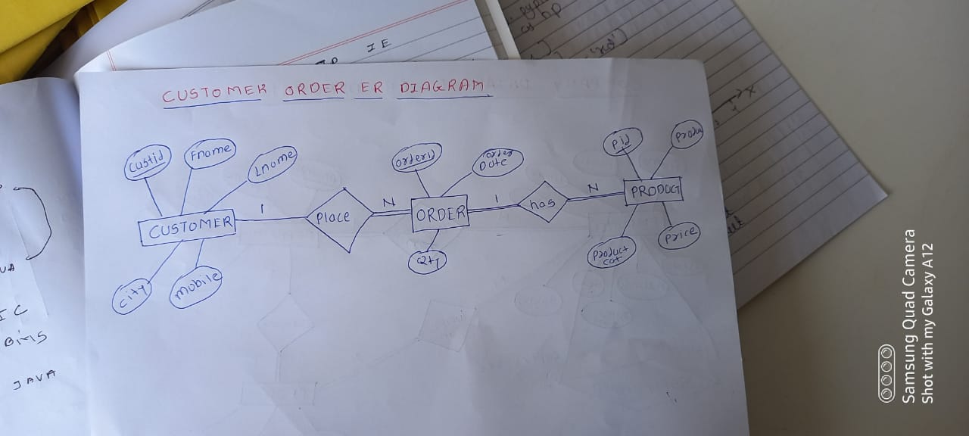

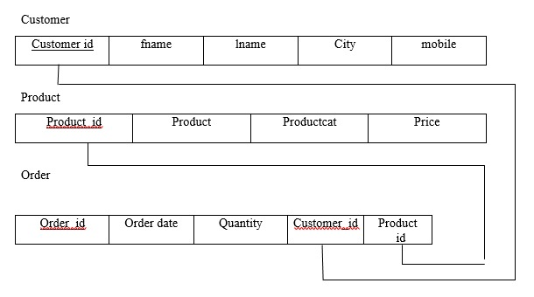

2) Create above tables by properly specifying primary and foreign keys.

create table customer282

(custid number (4) primary key,

fname varchar (10) not null,

lname varchar (10) not null,

city varchar (20),

state varchar (20),

mobile_no number (10),

check(length(mobile_no)=10));

insert into customer282 values(1,'Sona','Rao','Belagavi','Karnataka',8652379561);

insert into customer282 values(2,'Manish','Kumar','Belagavi','Karnataka',8978451263);

insert into customer282 values(3,'Manali','Rane','Belagavi','Karnataka',8451263100);

insert into customer282 values(4,'John','Fernandes','Belagavi','Karnataka',9078451263);

insert into customer282 values(5,'Ayesha','Desai','Banglore','Karnataka',9578451261);

insert into customer282 values(6,'Soniya','Patil','banglore','Karnataka',9878451263);

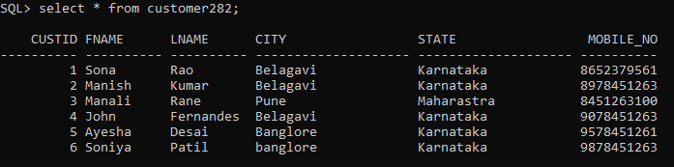

create table product282

(productid varchar(10) primary key,

productcat varchar(15),

product varchar(25),

price decimal(10,2));

insert into product282 values('P001','Electronics','Samsung S23',115000);

insert into product282 values('P002','Electronics','Bajaj fan',1500);

insert into product282 values('P003','Electronics','Voltas AC',1500);

insert into product282 values('P004','Home decor','Table lamps',1500);

insert into product282 values('P005','Clothing','Levis jeans',8000);

insert into product282 values('P006','Clothing','Puma tshirt',3000);

insert into product282 values('P007','Home app','Microwave',5000);

insert into product282 values('P008','Home app','Refrigerator',20000);

insert into product282 values('P009','Stationary','Navneet notebook',200);

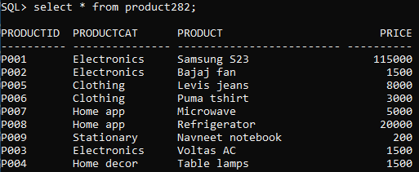

create table order282

(orderid number (4) primary key,

orderdate date,

custid number (4) references customer282 (custid),

pid varchar(10) references product282 (productid),

qty number(5));

insert into order282 values(111,'1-May-2024',1,'P001',2);

insert into order282 values(112,'30-April-2024',2,'P002',1);

insert into order282 values(113,'1-May-2024',1,'P004',2);

insert into order282 values(114,'1-May-2024',1,'P006',1);

insert into order282 values(115,'1-May-2024',1,'P005',3);

insert into order282 values(116,'4-April-2024',3,'P003',4);

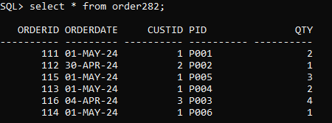

1. Find customer name start with S**o**

select * from customer282 where fname like 'So%';

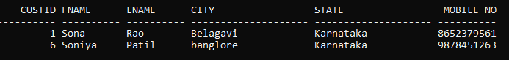

1. Find product wise product count.

select productcat,count(*) from product282 group by productcat ;

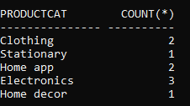

1. Find Order Date and Product.

select orderdate,product,productcat from order282,product282 where pid=productid;

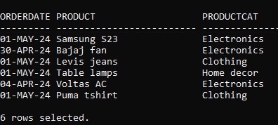

1. Display fname, lname of the customer with product.

select fname,lname,product,productcat from customer282,product282,order282

where customer282.custid=order282.custid and product282.productid =order282.pid;

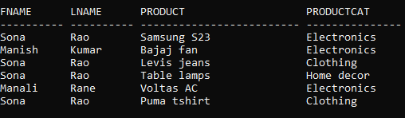

1. Display fname, lname of the customer with product and amount.

select fname,lname,product,qty*price as amount

from customer282,order282,product282

where customer282.custid=order282.custid and

product282.productid=order282.pid;

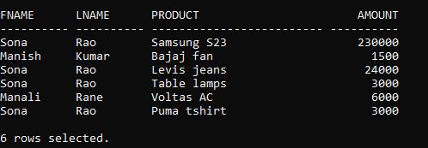

1. Update the address of customer Manali from Pune to Bengaluru.



update customer282 set city='Bengaluru',state='Karnataka' where custid=3;

